Compact Mono Multifunction Printer with Duplex Print
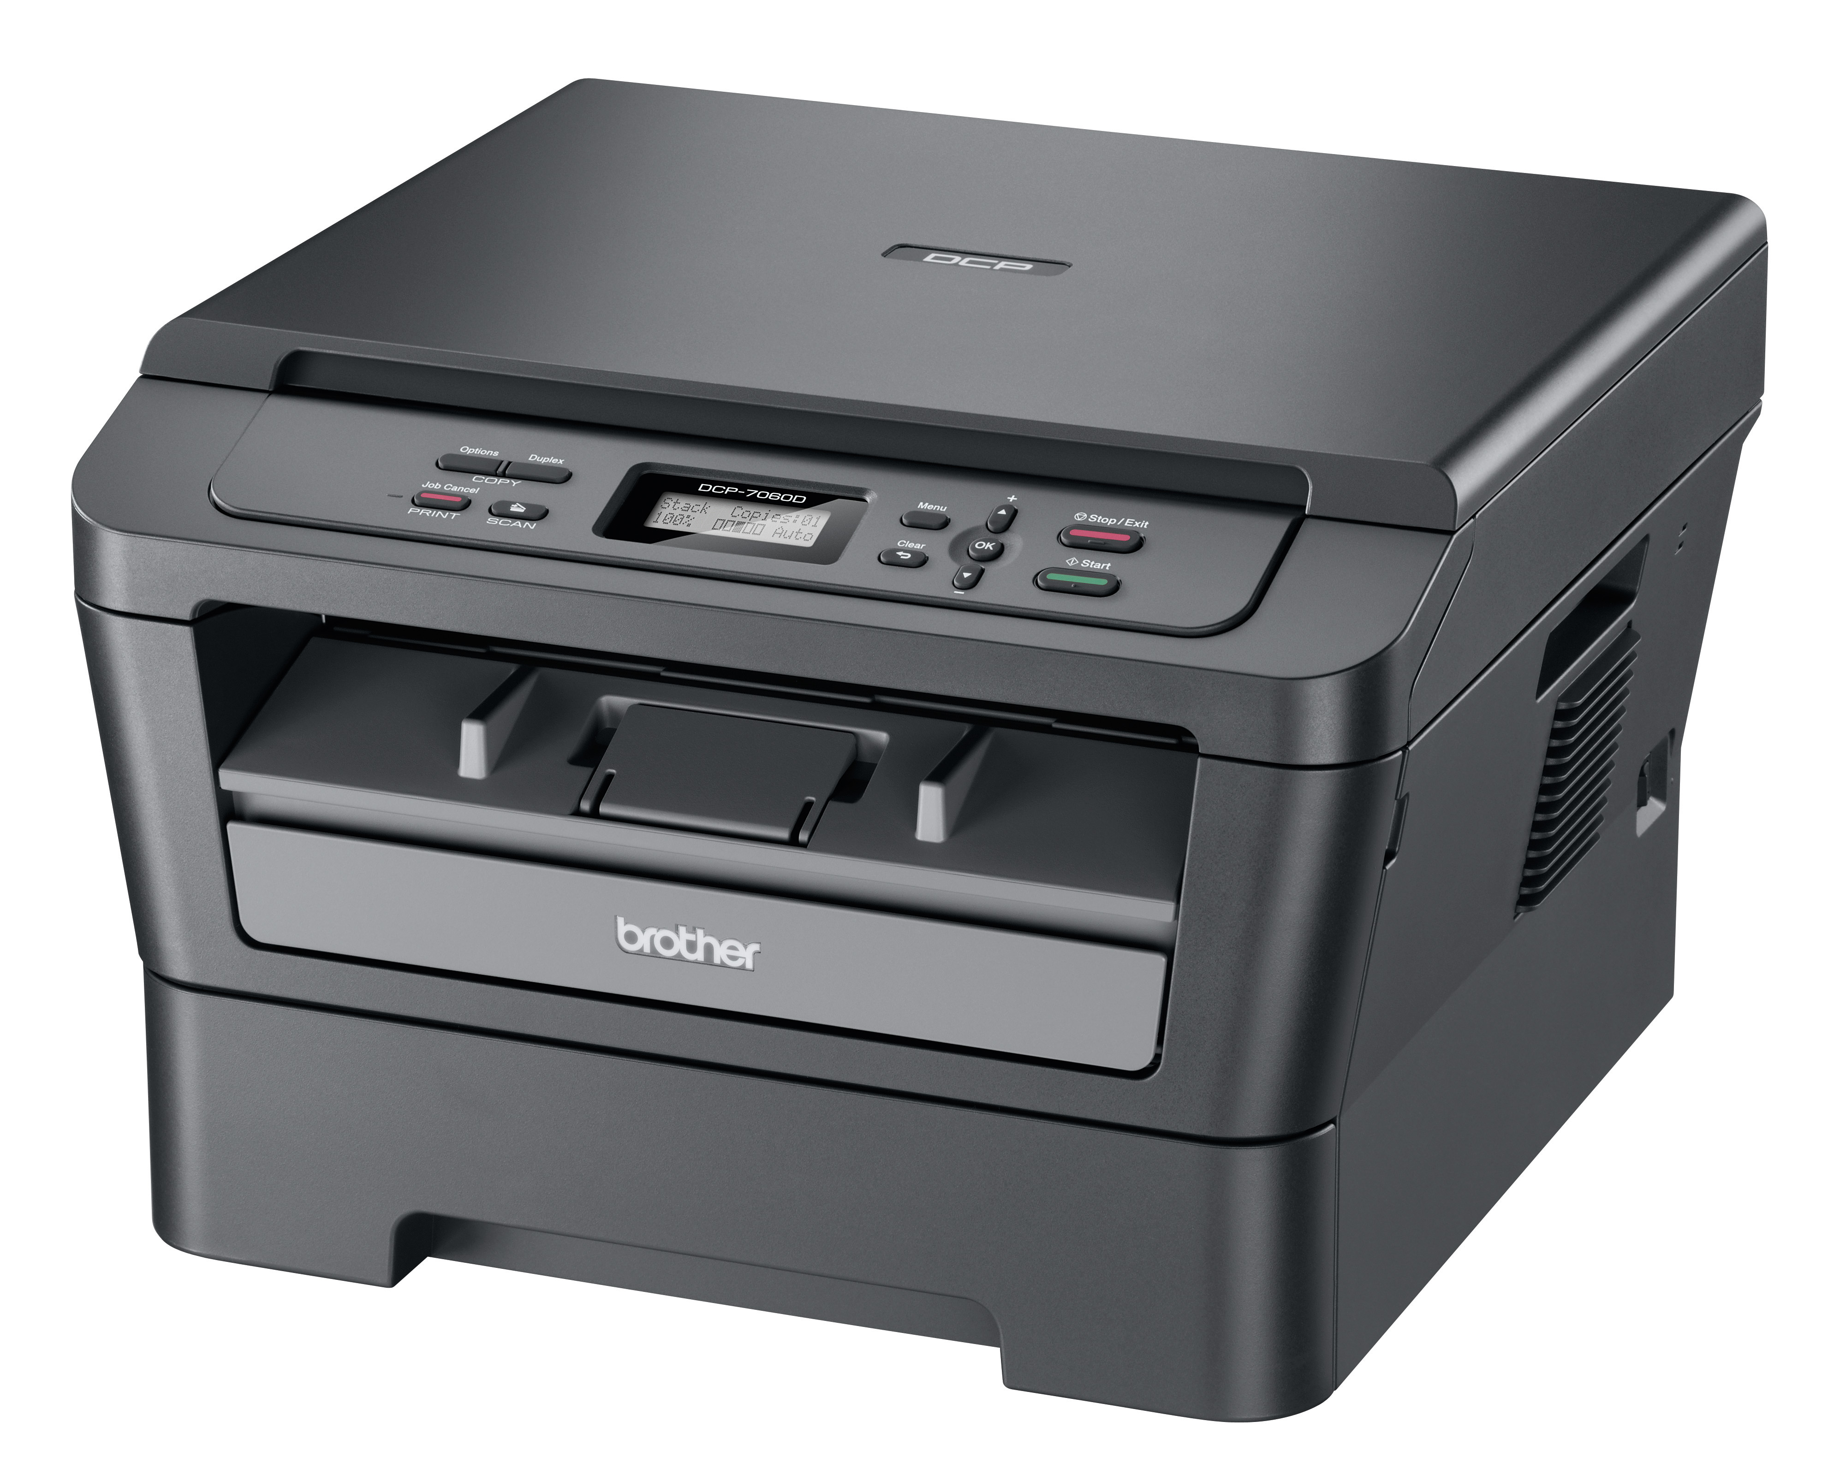

Duplex Mono Printer
Mono Copier
Colour Scanner

COLOUR SCANNER

Up to 600 x 2,400 dpi resolution (optical)
Up to 19,200 x 19,200 dpi resolution (interpolated)
48 bit internal colour depth (24 bit external)
Scan key for e-mail, image, OCR and file†
Twain (WIA††) Compliant

† Requires the Brother Control Centre Software
†† For Windows® 7, Windows Vista® & Windows® XP

CORE FEATURES

Up to 24ppm (pages per minute) print speed
Automatic double sided (duplex) print
Attractive flatbed design
Hi-Speed USB 2.0 interface
1 sheet manual paper feed slot
250 sheet paper capacity
32MB memory
2 lines x 16 characters LCD

General
MONO COPIER

Up to 24cpm (copies per minute) copy speed
Up to 600 x 600dpi resolution
Up to 99 multi-copies with stack feature
Save paper by copying 2 or 4 pages to a single page

MONO PRINTER

Up to 24ppm print speed
HQ1200 (2,400 x 600 dpi) quality
GDI (host based) print language
Straight paper path
Recommended monthly print volume 250 – 2,000 pages
Maximum monthly volume 10,000 pages

Engine Electrophotographic Laser
Processor ARM946E-S 200MHz
Local Interface Hi-Speed USB 2.0
LCD Display Size 2 lines x 16 characters
Memory Capacity 32MB (RAM)
On / Off Switch Yes

Mono Printer
Print speed (simplex) 24 pages per minute
Print speed (duplex) 5 sheets per minute
Resolution HQ1200 (2,400 x 600 dpi) quality
First Print Out Time [From Ready Mode] Less than 8.5 seconds
Warm Up Time [From Sleep Mode] Less than 7 seconds
Emulation GDI (host based)

Mono Copier
Speed Up to 24cpm (copies per minute)
First Copy Out Time (From Ready Mode) Less than 11 seconds
Resolution 600 x 600 dpi
Multi-Copying / Stack Makes up to 99 copies of each page
Enlargement / Reduction Ratio Easily copy documents to a required paper size (25% to 400% in 1% increments).
Save Paper Copy 2 or 4 pages to a single page (N-up copying)

Colour Scanner
Resolution (Optical) Up to 600 x 2,400 dpi
Resolution (Interpolated) Up to 19,200 x 19,200 dpi
Colour Depth 48bit internal / 24bit external colour scanner
Grey Scale 256 shades of grey are available for copying or scanning
TWAIN Scanner Compliance Windows® 7, Windows Vista®, Windows® XP, Windows® 2000 and OS X 10.3.9 or greater
WIA Scanner Compliance Windows® 7, Windows Vista®, Windows® XP
SANE Scanner Compliance Linux
Scan To E-mail, image, OCR, file (Requires the Brother Control Centre software)
Scan Key Enables user to scan a document to e-mail, image, OCR, file using the scan key (Requires the Brother Control Centre software)
Printer Driver
Windows® Windows 7® (32 & 64 bit editions), Windows Vista® (32 & 64 bit editions), Windows XP Home Edition, Windows XP Professional (32 & 64 bit editions), Windows® 2000 Professional, Windows® Terminal Services 2003 & 2008†††, Citrix Presentation Server†††®, Citrix XenApp†††®, Citrix XenDesktop†††®
Apple Macintosh Mac OS X 10.4.11 or greater
Linux*** CUPS printing system(x86, x64 environment), Linux printer driver for LPD/LPRng printing system(x86, x64 environment)

Printer Driver Installation Options
Installation Wizard An easy to use wizard that will guide you through whole installation process
Printer Driver Only Install only the printer driver using your own installation method
Driver Deployment Wizard [DDW] Guides you through the printer driver install and creates an executable file that can be used to install the printer driver on other PC’s (Windows® only).
Printer Driver Functions
N-up Printing (Windows® & Mac only) Reduce up to 2, 4, 9, 16 or 25 A4 pages into just one A4 page
Poster Printing † Enlarge 1 A4 page into a poster using 4, 9, 16 or 25 A4 pages
Watermark Printing † Watermark your documents with predefined text or with your own user-defined messages
Automatic Duplex † Automatically print to both sides of a piece of paper
Booklet Printing † Print documents in A5 Booklet format using automatic duplex

Remote Management Utilities
E-mail reports Reports containing basic usage data sent to a nominated e-mail address on a cyclical basis. This feature requires the Brother BRPrint Auditor application*** to be installed onto the same computer as the DCP-7055 / 7057.
E-mail notifications Alerts sent to a nominated e-mail address when anything which can disrupt printing activity occurs. This feature requires the Brother BRPrint Auditor application*** to be installed onto the same computer as the DCP-7055 / 7057.

Paper Handling
Paper Input**
Standard Tray: 250 sheets
Manual paper feed slot: 1 sheet

Paper Output**
Face Down (standard output): 100 sheets
Face Up: 1 sheet (straight paper path) 1 sheet

Media Specifications
Media Types
Standard Tray Plain paper, thin paper, recycled paper
Manual paper feed slot: Plain paper, thin paper, thick paper, recycled paper, bond paper, labels and envelopes

Media Weights
Standard Tray: 60 – 105g/m²
Multi-Purpose Tray: 60 – 163g/m²

Media Sizes
Standard Tray: A4, letter, B5(ISO/JIS), A5, A5 (long edge), B6(ISO), A6, executive
Multi-Purpose Tray: Width (76.2 – 220mm) x length (116.0 x 406.4)

List / Report
System Set-up List A printed report that shows the current setting of your machine.

Page Counters - Available to view in LCD & printed report
Total Print Pages Informs the user of the total number of all pages produced from this machine
Copy Pages Informs the user of the total number of copies made on this machine in pages
PC Print Pages Informs the user of the total number of PC prints from this machine
Report Pages Informs the user of the total number of reports printed on this machine in pages

Supplies
Standard toner (TN-2210) 1,200 pages*
High yield toner (TN-2220) 2,600 pages*
Drum (DR-2200) 12,000 pages

The frequency of replacement of consumables will vary depending on the complexity of the prints, the percentage of coverage, paper size, page per job, and the type of media.

Dimensions & Weights
With carton & consumanbles 527 (W) x 510(D) x 440(H) mm, 13.2Kg
Without carton, with consumanbles 405 (W) x 398.5 (D) x 268(H) mm, 10.1Kg

Power Consumption
Printing Average 445W at 25c
Ready Average 55W at 25c
Deep sleep Average 0.9w at 25c

Sound Pressure Level
Printing Less than 53 dB
Ready Less than 30 dB

Sound Power Level
Printing Less than 6.40B
Ready Less than 4.27B

Ecology
Typical Electrical Consumption (TEC) 1.117 kWh / week
Power Saving This enables the machine to consume less energy when not in use.
Toner Saving This reduces the toner usage and helps to reduce the total cost of printer ownership.
Energy Star Certified to the world-wide eco label for power consumption.

Duty Cycles
Recommended 250 – 2,000 pages monthly print volume
Maximum 10,000 pages monthly print volume

Contents
Toner cartridge: up to 700 pages*
Drum unit: up to 12,000 pages
Power supply cord
Driver software for Windows® & Apple Macintosh
User Guide (CD-ROM)
Quick Set-up Guide
PC interface cable NOT included

† For Windows only
†† Requires the Brother Control Centre Software
††† For USB printing only.
*Approx. yield is declared in accordance with ISO/IEC 19752
**Calculated with 80g/m² paper
*** Downloaded free of charge from Brother’s Solutions Centre http://solutions.brother.com


